**SONAR QUBE & SONAR SCANNER**

**Prerequisites**

* **SonarQube** - SonarQube® software (previously called Sonar) is an open source quality management platform, dedicated to continuously analyze and measure technical quality, from project portfolio to method.
* **Sonar** **Scanner** - The SonarQube Scanner is recommended as the default launcher to analyze a project with SonarQube.
* **Java 8**

**For Example(**we have used **{**sonarqube(4.5.7) and sonarscanner(2.5)})

**Installing & Configuring SONAR**

1. Download from the below site (sonar-4.5.7.zip )

<http://www.sonarsource.org/downloads/>

1. Unzip the zip file (sonar-4.5.7.zip) to a folder of your choice
2. Edit the sonar.properties file in the conf folder. (e.g D:<sonar_home>/conf/sonar.properties )

Uncomment the following lines in the sonar.properties

|  |
| --- |
| *sonar.jdbc.maxActive =20*  *sonar.jdbc.maxIdle =5*  *sonar.jdbc.minIdle =2*  *sonar.jdbc.maxWait =5000*  *sonar.jdbc.minEvictableIdleTimeMillis=600000*  *sonar.jdbc.timeBetweenEvictionRunsMillis=30000*  *sonar.web.port =9081*  *sonar.search.port =9010* |

1. Run StartSonar.bat in the <sonar_home>/bin/windows-x86-32 folder

Example : D:<sonar_home>\ bin\windows-x86-32>StartSonar.bat

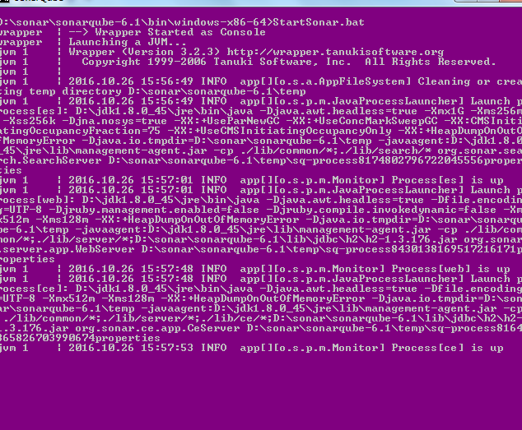

now in browser : localhost :9081,

sonarqube installed and configured successfully!!!

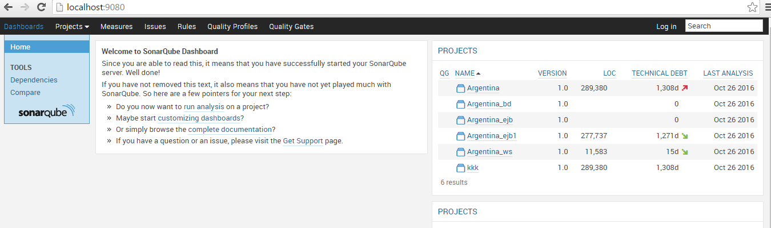

**Installing & Configuring SONARSCANNER**

1. Download SONARSCANNER from the below site (sonar-scanner-2.5.zip )

<http://www.sonarsource.org/downloads/>

1. Unzip the zip file (sonar- scanner -2.5.zip) to a folder of your choice
2. Update the global settings (database connection, server URL) by editing the file (<sonar_scanner_HOME>\ sonar-scanner-2.5\conf\ sonar-runner.properties )

|  |
| --- |
| #Configure here general information about the environment, such as SonarQube DB details for example  #No information about specific project should appear here  #----- Default SonarQube server  #sonar.host.url=http://localhost:9000  sonar.host.url=http://localhost:9081  #----- Default source code encoding  #sonar.sourceEncoding=UTF-8  #----- Global database settings (not used for SonarQube 5.2+)  #sonar.jdbc.username=sonar  #sonar.jdbc.password=sonar  #----- PostgreSQL  #sonar.jdbc.url=jdbc:postgresql://localhost/sonar  #----- MySQL  #sonar.jdbc.url=jdbc:mysql://localhost:3306/sonar?useUnicode=true&amp;characterEncoding=utf8  #----- Oracle  #sonar.jdbc.url=jdbc:oracle:thin:@localhost/XE  #----- Microsoft SQLServer  #sonar.jdbc.url=jdbc:jtds:sqlserver://localhost/sonar;SelectMethod=Cursor |

1. Edit the sonar-runner.properties file in the conf folder

# -- Project specific configuration ------------

#---------over all in sonar source----------------

#sonar.projectKey=Code

#sonar.sources=D:\\sonar\\New_version\\source

#sonar.projectName=Argentina

#sonar.projectVersion=1.0

#----------EJB----------------------------

#sonar.projectKey=Source_ejb

#sonar.sources=D:\\sonar\\New_version\\source\\EJB

#sonar.projectName=Argentina_ejb1

#sonar.projectVersion=1.0

#---------WS----------------------------

#sonar.projectKey=Source_ws

#sonar.sources=D:\\sonar\\New_version\\source\\WS

#sonar.projectName=Argentina_ws

#sonar.projectVersion=1.0

#---------BD----------------------------

sonar.projectKey=Source_bd

sonar.sources=D:\\sonar\\New_version\\source\\BD

sonar.projectName=Argentina_bd

sonar.projectVersion=1.0

1. Create a new SONAR_RUNNER_HOME environment variable

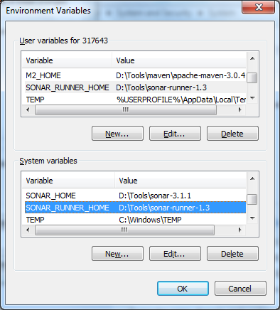

6.In the command prompt navigate to source folder



7. From there we have to navigate to <sonar_scanner_home>/bin/sonar_runner.bat and run the command



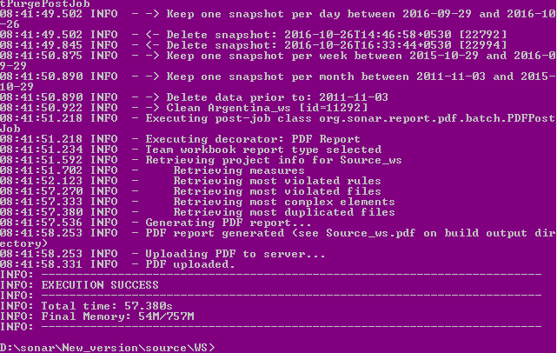

Sonarscanner installed and configured successfully!!!



**PDF Generation**

PDF report is only applicable for particular versions(sonarqube(4.5.7) &sonarscanner(2.5))

Steps:

Please find the latest PDF plugin for SonarQube (Open source from Kapic).

Follow the below steps to execute PDF report:



* Unzip the above pdf report-plugin Copy the JAR file in [SonarQube Home]/ extensions/plugins folder and remove if you have any previous versions.
* Restart the SonarQube Server
* Add the PDF widget for your project dashboard (from Administrator login)

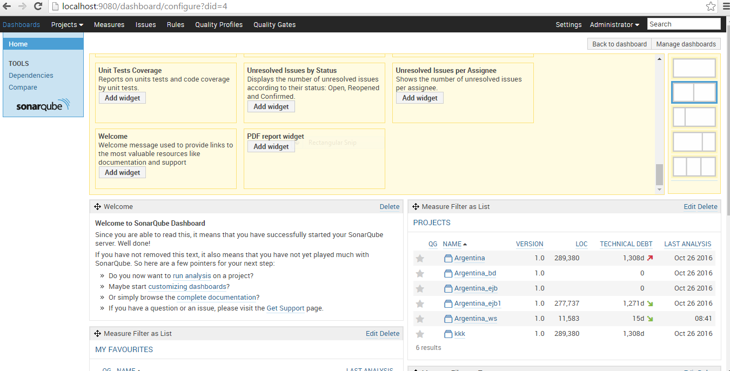

* Execute the project using Sonar Scanner and check the PDF report is generated or not.

IF successful download the report from Project Dashboard

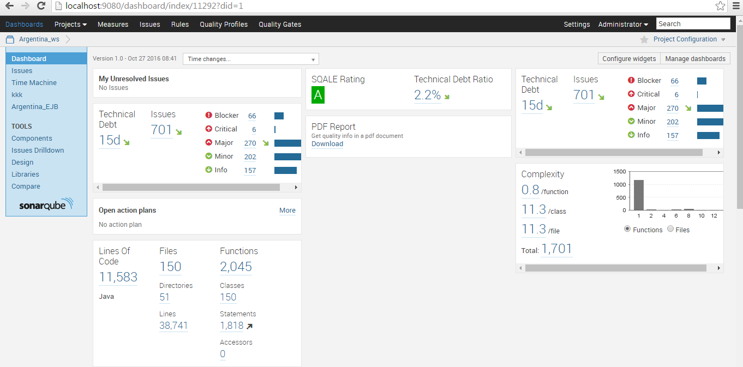

Now we are ready to analyze a project with Sonar Scanner

**References**

<http://docs.sonarqube.org/display/SONAR/Update+Center>

<https://maven-eu.nuxeo.org/nexus/content/repositories/public/org/codehaus/sonar-plugins/>

**Error-reference**

<http://stackoverflow.com/questions/27397173/sonarqube-4-5-1-initial-installation-with-oracle-database>